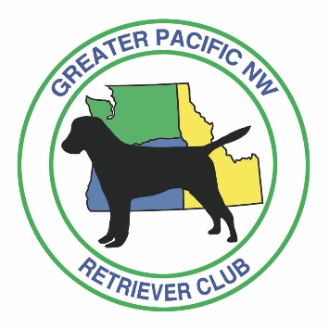
GREATER PACIFIC NW RETRIEVER CLUB
Membership Form
Name ____________________________________________ Home Phone ( _______) _______ - ________
Address ___________________________________________ Cell Phone ( _______) _______ - ________
___________________________________________ Work Phone ( _______) _______ - ________
City, State, Zip ____________________________________
E-Mail Address ____________________________________ Occupation__________________________________
Provide a brief summary of your interest in retriever-breed dogs and the sport of field trials/hunt tests.
Number of dogs currently owned? Titles earned? Titles you hope to earn? Also, please check all that apply:
□ Volunteer for field events | □ Veterinary experience | □ Bird hunter
□ Experienced at field events | □ Experience with firearms | □ Other _____________________
____________________________________________________________________________________________________________
____________________________________________________________________________________________________________

APPLICANT’S CERTIFICATION:
I agree to abide by the constitution, bylaws, and rules of The American Kennel Club and the bylaws and rules of The Greater Pacific Northwest Retriever Trial Club. I am presently in good standing with The American Kennel Club. In the event The American Kennel Club initiates disciplinary action upon me, or my standing with the American Kennel Club should be questioned, I will promptly inform the President of The Greater Pacific Northwest Retriever Trial Club, Inc. (the “Club”) of such. I authorize the Club to use e-mail to provide me with all notices required under the bylaws of the Club. I release the Club from any and all liability should such required notices be received late or not at all due to circumstances beyond the Club’s control.
APPLICANT’S ACKNOWLEDGEMENT
Print Name ____________________________________ Signature ______________________________________________

Note: $40.00 Annual membership dues are required at the time of application
Please make checks payable to: Greater Pacific NW Retriever Club or GPNWRC

Mail dues to
Greater Pacific NW Retriever Club
1030 Rafael Ave. N.
Keizer, Oregon 97303

How did you hear about us? ______________________________________________________________________________

